2019 WA1500 WORLD CHAMPIONSHIPS
ENTRY FORM
CLOSING DATE 21stJuly 2019

Electronic Banking Details for direct deposit of fees.
World WA1500 Entry Fees BSB: 062 172 ACCOUNT: 104 851 46 Swift Code: CTBAAU2S

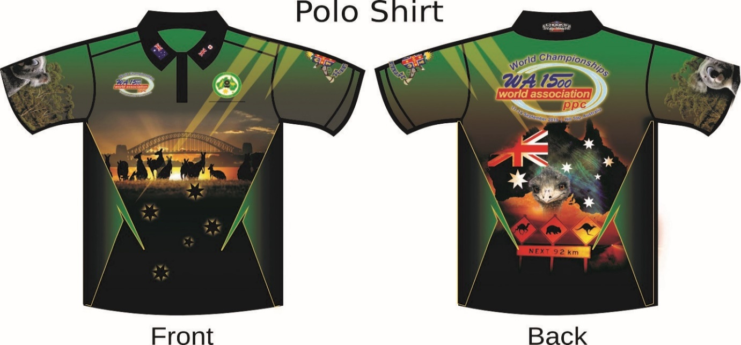

Please include your WAID Number on Remittance / Payment
Please email to : landmjones@jonesgulgong.com.au

Contact Details:
Organising Secretary: Marnie Jones Email: landmjones@jonesgulgong.com.au
Phone: +61 (0 ) 428535441

